Inquiry Project 4: Defining Functions

Part 1: Simulating Relationships
 | Online Activity  Access the interactive simulator to begin this project. | 
Today you are going to investigate something called an interactive simulation. It is a tool that will help you visualize how functions work.
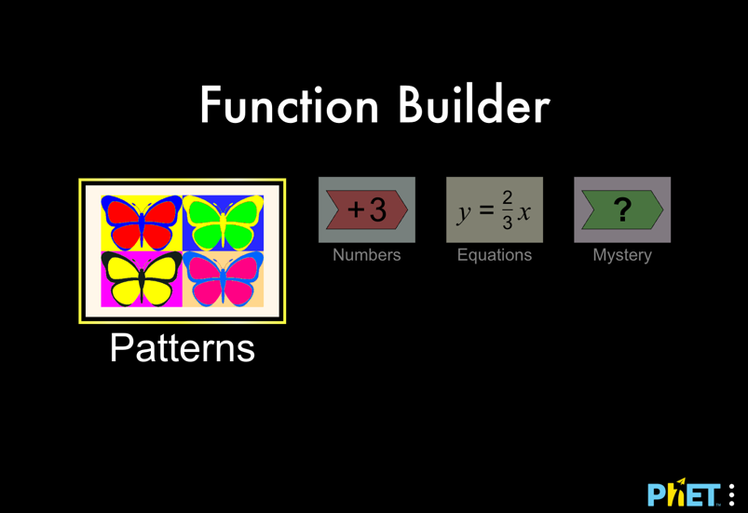
Step 1 - Open the interactive simulator, Function Builder in your web browser. You will use it to complete this project. It will look like the image to the above.
Step 2 - Play with any of the screens on the Function Builder for 5 minutes.
Step 3 - As you discover how the tool works, share your thinking with your group members. You may want to use the following question and sentence stem to guide your discussions:
- What did you try? What happened?
- I tried … and it caused … to happen.
Step 4 - Write down two things you notice or have questions about, and one thing a neighbor noticed that is interesting to you.

Part 2: What is a function?
In this activity, whenever you see 💬, stop and share your responses with your partner. If you have different responses, try to come to a consensus.
In the first activity, you may have noticed that all of the simulation screens share a three-part structure. These three parts can be described in a variety of ways, such as the ones listed in the image.
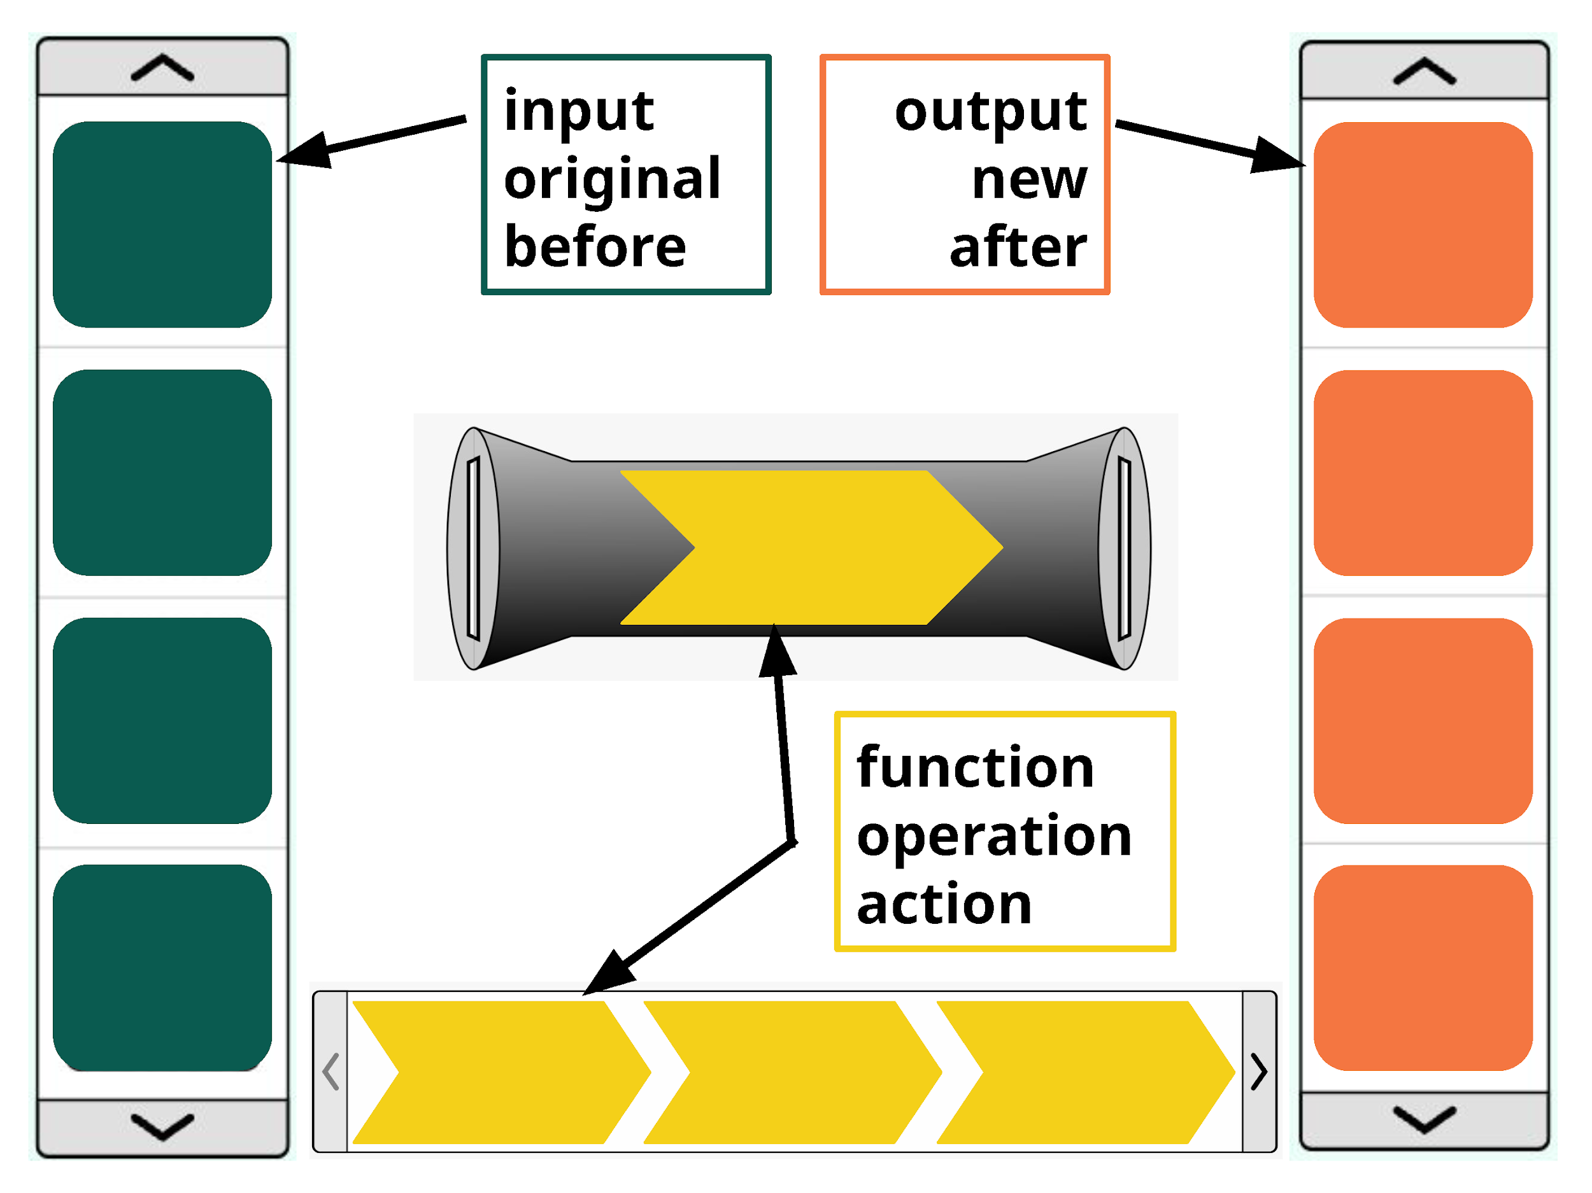
- Come up with your own names or labels for the three parts of a function.
- Share your labels with your group. Write down any similarities.
For questions 3-4, use the following instructions.
Use the simulation screen labeled “Patterns”. Note you can switch between simulation screens using the toolbar located below the function builder. The blue “builder” in the middle of the screen is a function.
- Describe what a function is using the labels you've agreed on as a class. 💬
- Suppose you build this function:
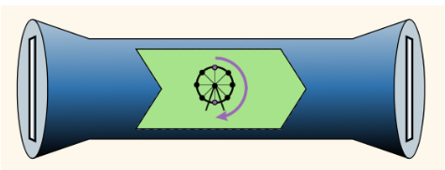
  - Complete the following table, sketching what happens after going through the function.
Input | Output
 | 





  - Write a rule that describes what the function does. Compare with your group.

Part 3: Different Kinds of Functions
In this activity, whenever you see 💬, stop and share your responses with your partner. If you have different responses, try to come to a consensus.
For questions 1-3, use the following instructions.
Use the simulation screen labeled “Numbers”. Note you can switch between simulation screens using the toolbar located below the function builder.
- Build a function. Fill in the function builder and table. Access the input and output information by clicking the gray tabs above and below the function builder.
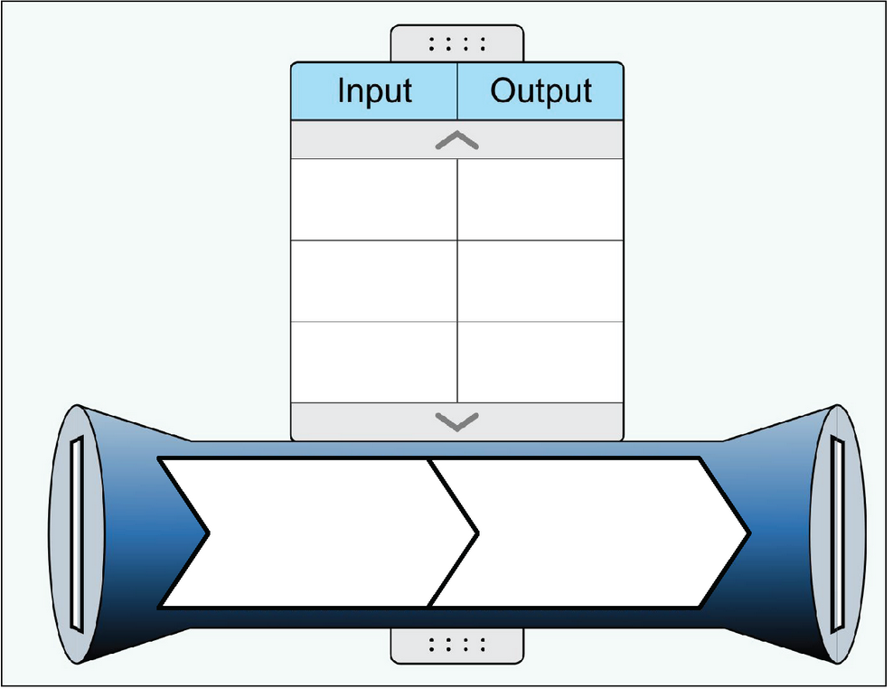
- What is the output when the input is 10? Switch papers with a teammate and check that you found the correct output. 💬
- Describe how to find the output for your function if given any input. Challenge yourself to describe in multiple ways.
For questions 4-8, use the following instructions.
Use the simulation screen labeled “Equations”. Note you can switch between simulation screens using the toolbar located below the function builder.
- Build a custom function. Fill in the function builder and representations. Access the table and graph information by clicking the gray tabs above and below the function builder.
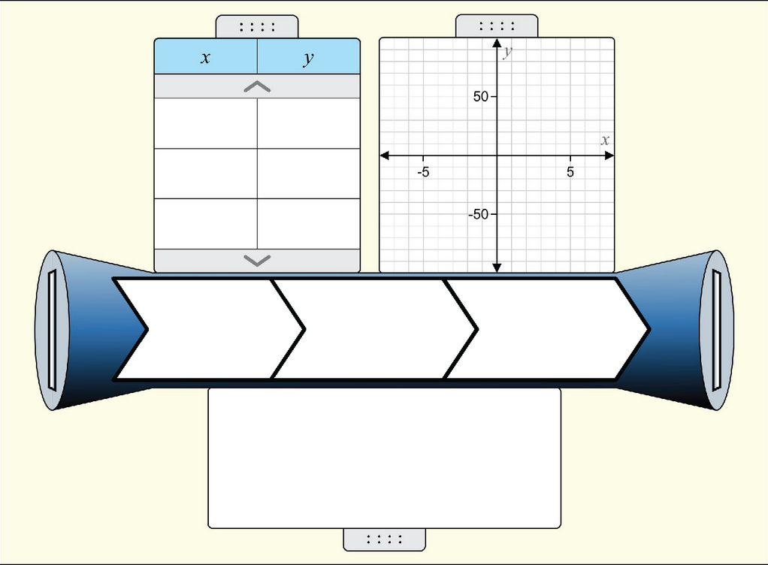
- What is $y$ when $x$ is 100?
- Manipulate your function in different ways. Describe the effects on the table, graph, and equation that each of your actions has.
Action | Effect on table | Effect on graph | Effect on equation
Click the up arrow on the addition operation
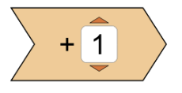
- What does your graph look like? What other graphs can you make?
- Briefly describe how different operations impact the graph of your function.
  - Addition
  - Subtraction
  - Multiplication
  - Division

Extension
Play with the game! Challenge yourself to figure out the mystery functions. They get tricky when you have two or three operations. Does your rule match the simulation's rule? Can there be more than one answer?
 | Online Activity  Access the mystery functions game for an extra challenge. | 

